R07922141

張緣彩

11/24/2018

Computer Vision HW8 Report

* **Implementation**

**Signal-to-Ratio (SNR)** function is same as the equations described in website.

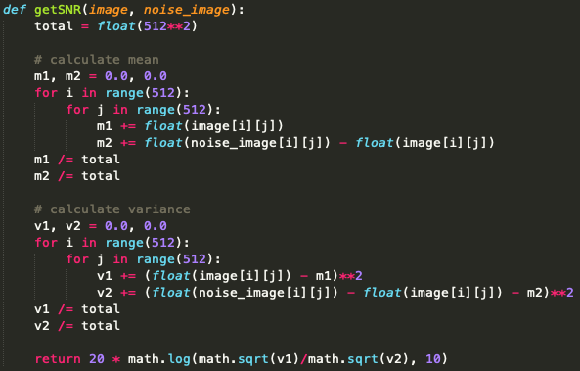

**Gaussian noise** generate function is same as the equation described in the lecture note. Given Img[x, y] = Img[x, y] + amp*gaussian distribution(0, 1) with mean of 0 and standard deviation of 1.

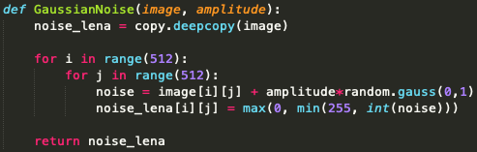

**Salt and Pepper noise** generate function is also same as the equation described in the lecture note. Given a probability, sample a value from uniform distribution of (0, 1) then if the value is smaller than the probability or larger than 1 - probability. The pixel will be given 0 or 255 respectively, otherwise it is original value.

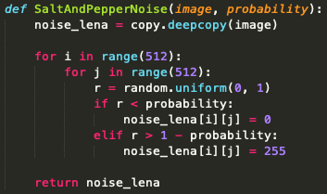

**Box filter** function is same as the equation described in the lecture note. Given a kernel, the value of the pixel is actually the mean of its neighbors. I use a list to save its neighbor’s value then calculate its mean and assign back to it.

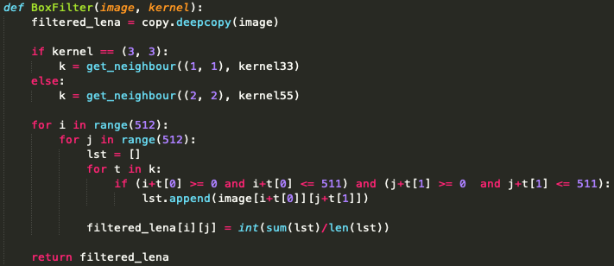

**Median filter** function is same as box filter (described in the lecture note as well). Then only different is we use the median of its neighbor instead of mean. Given a kernel, the value of the pixel is actually the median of its neighbors. I use a list to save its neighbor’s value then find the median from the list and assign back to it.

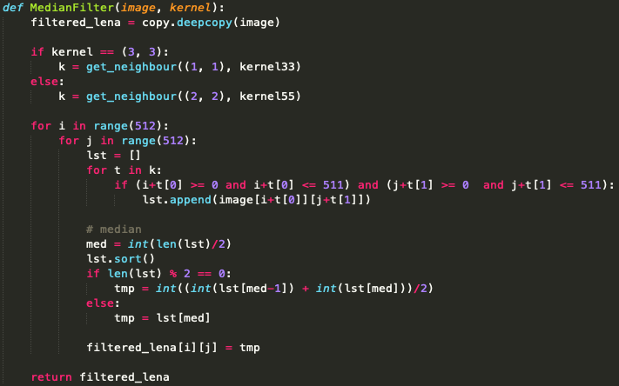

* **Result**

**SNR**

|  |  |  |  |  |  |  |  |
| --- | --- | --- | --- | --- | --- | --- | --- |
|  | **Noise** | **Box 3x3** | **Box 5x5** | **Med 3x3** | **Med 5x5** | **O then C** | **C then O** |
| **G 10** | 13.608 | 17.743 | 14.863 | 17.666 | 16.008 | 13.273 | 13.590 |
| **G 30** | 4.177 | 12.602 | 13.306 | 11.098 | 12.900 | 11.191 | 11.201 |
| **SAP 0.05** | 0.951 | 9.497 | 11.196 | 19.170 | 16.360 | 5.853 | 5.377 |
| **SAP 0.1** | -2.097 | 6.318 | 8.505 | 14.848 | 15.787 | -2.191 | -2.457 |

**IMAGE  
Gaussian noise - 10, 30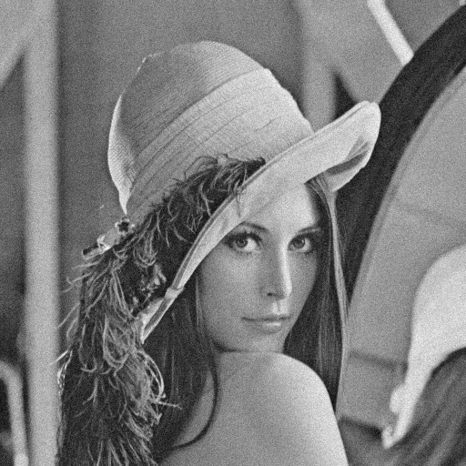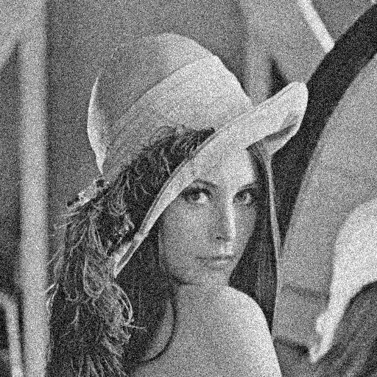 Salt and Pepper noise - 0.05, 0.1**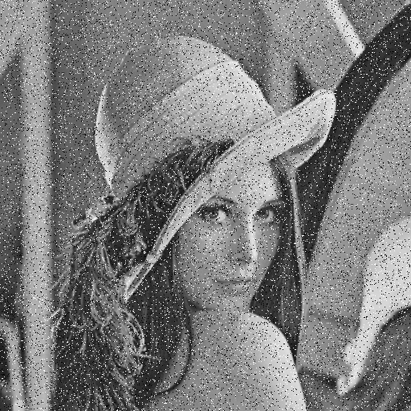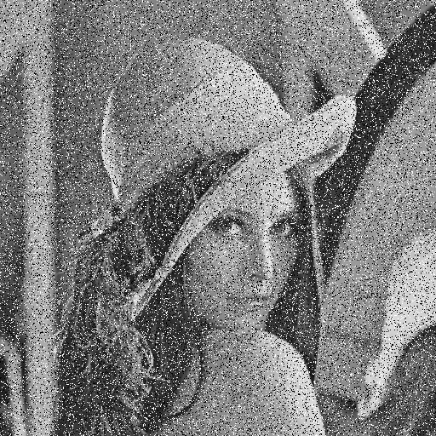

**Gaussian 10 - BOX filter - 3x3 5x5**

**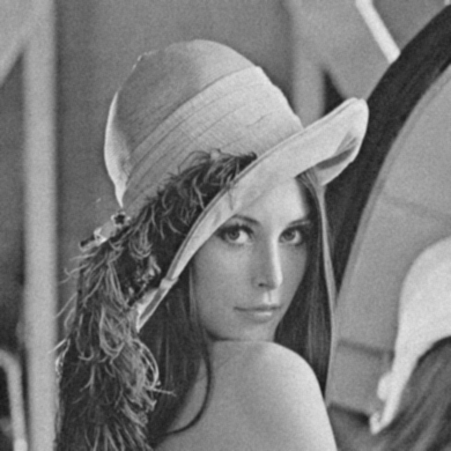 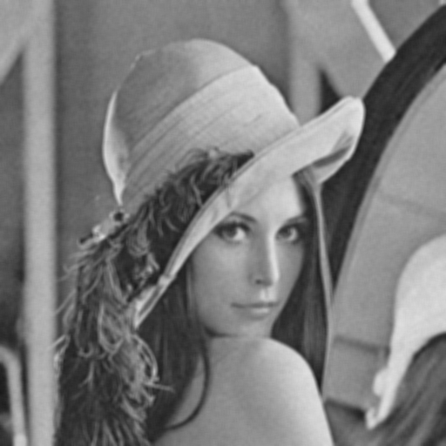  
Gaussian 30 - BOX filter - 3x3 5x5**

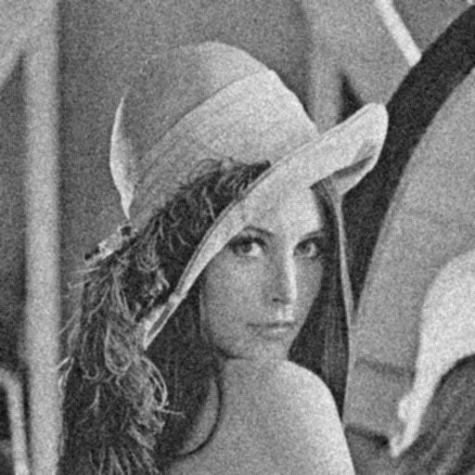 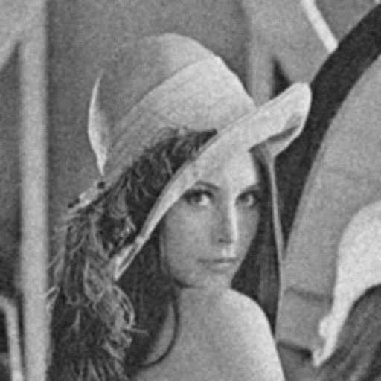

**Salt and Pepper 0.05 - BOX filter - 3x3, 5x5**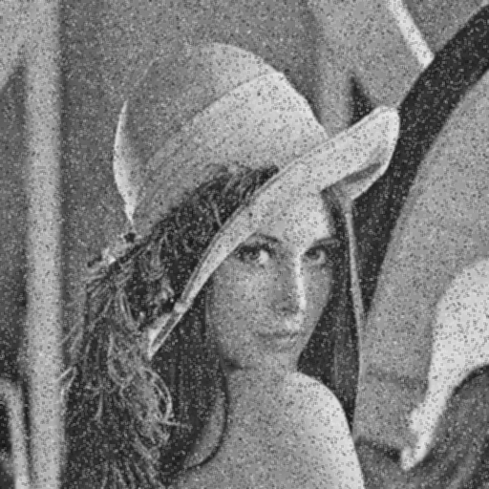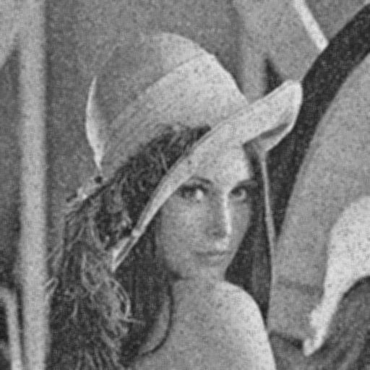

**Salt and Pepper 0.1 - BOX filter - 3x3, 5x5**

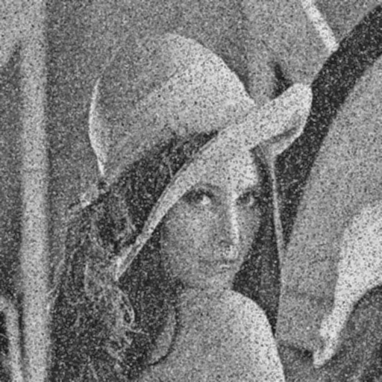 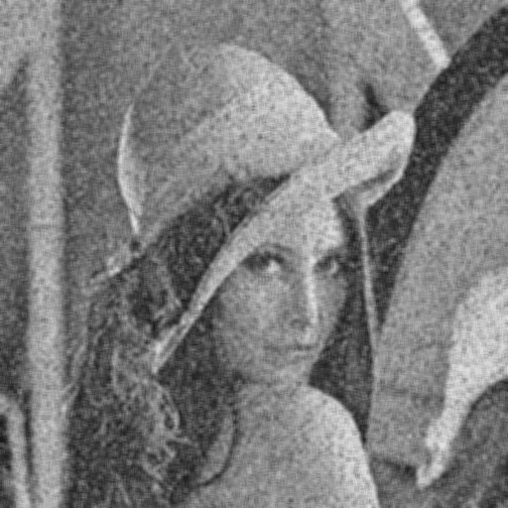

**Gaussian 10 - MEDIAN filter - 3x3 5x5**

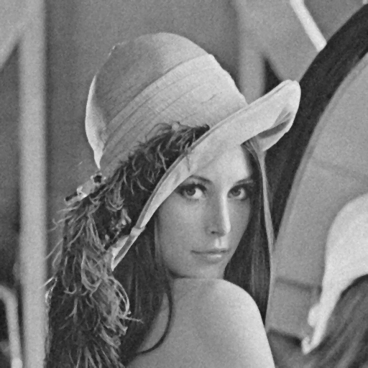 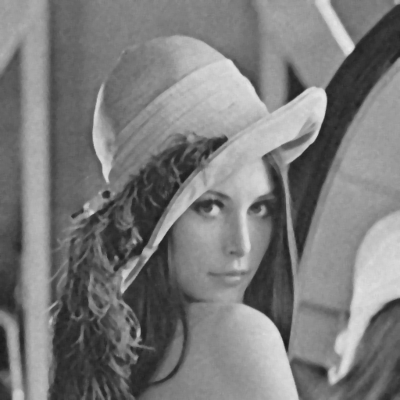

**Gaussian 30 - MEDIAN filter - 3x3 5x5**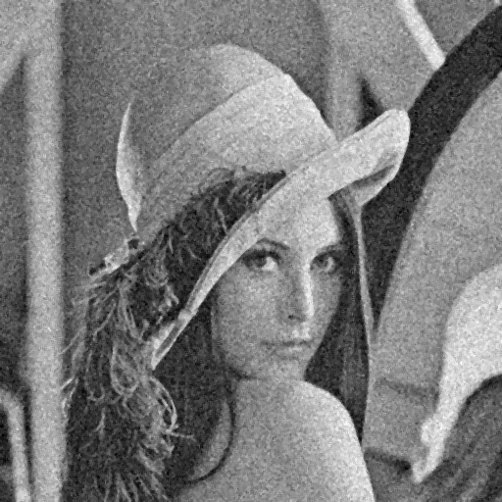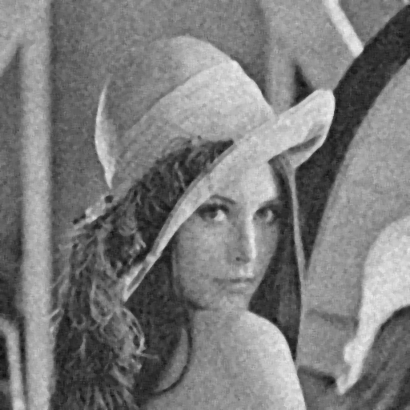

**Salt and Pepper 0.05 - MEDIAN filter - 3x3, 5x5**

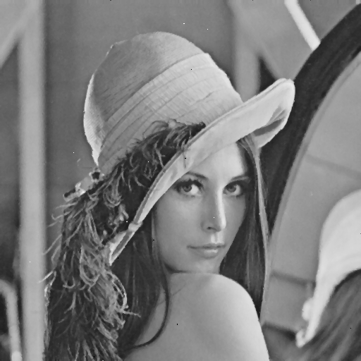 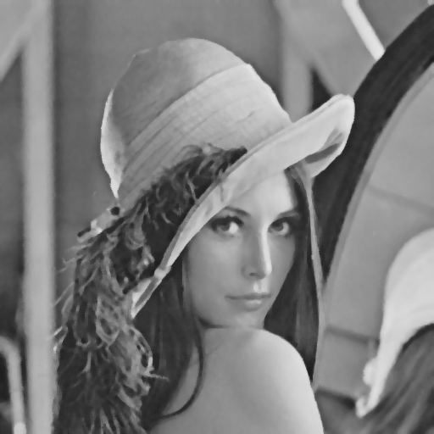

**Salt and Pepper 0.1 - MEDIAN filter - 3x3, 5x5**

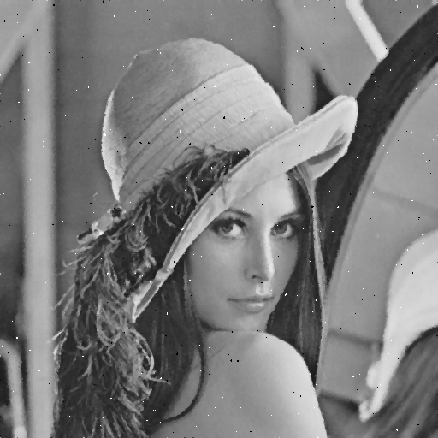 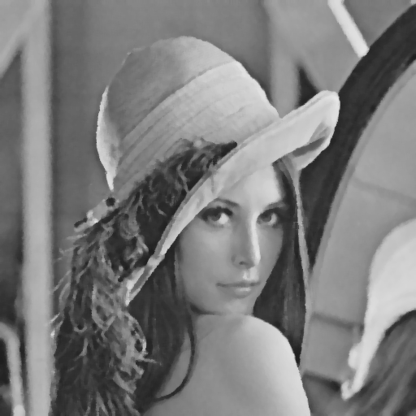

**Gaussian 10 – closing then opening, opening then closing   
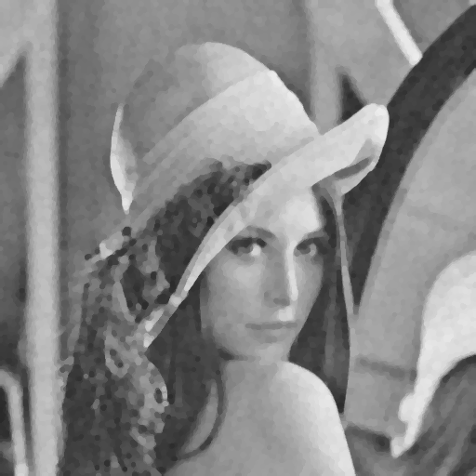 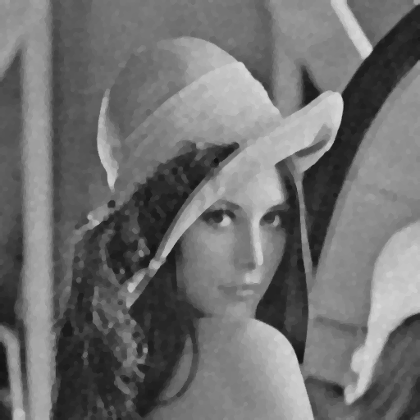**

**Gaussian 30 - closing then opening, opening then closing**

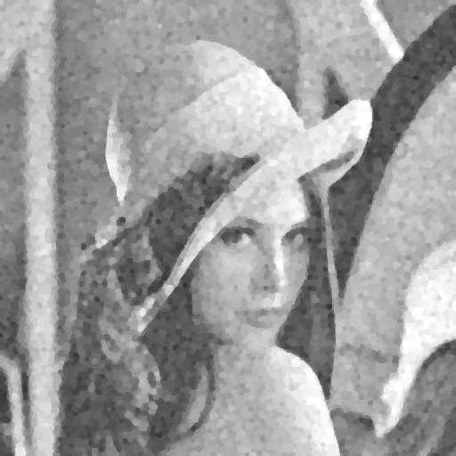 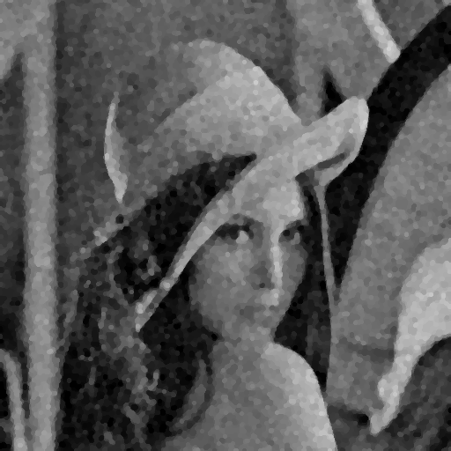

**Salt and Pepper 0.05 - closing then opening, opening then closing**

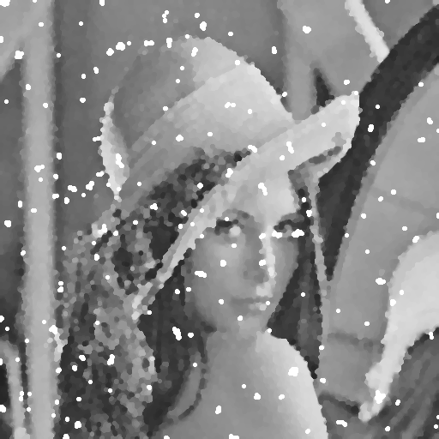 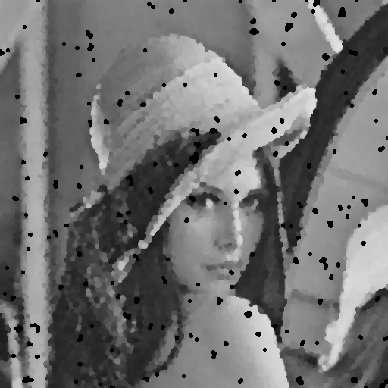

**Salt and Pepper 0.1 - closing then opening, opening then closing  
